Release Note – **Financial Widget Modification**

Quarterly Product Release

Version 24.1.0.0



C

ONTACTS

info@uppwise.com

[LinkedIn Company Profi](https://www.linkedin.com/company/uppwise)le

[www.uppwise.c](http://www.uppwise.com/)om

Quarterly Product Release Version 23.3.0.1



C

ONTACTS

info@uppwise.com

[LinkedIn Company Profi](https://www.linkedin.com/company/uppwise)le

[www.uppwise.c](http://www.uppwise.com/)om

This serves as a Feature Release Note to apprise our customers of the latest addition to the application, released with the Uppwise 2024 **Quarter 1 release 24.1.0.0**

# Feature: Financial Widget Modifications

We are thrilled to announce the release of our latest feature development aimed at enhancing user flexibility and functionality within our platform. Below are the key highlights of this release:

**Feature Description:**

* **Custom Column Naming:** Users now have the ability to customize column labels directly from the initiative custom field settings area. This feature allows for seamless modification of column names based on individual preferences, empowering users to personalize their workspace.

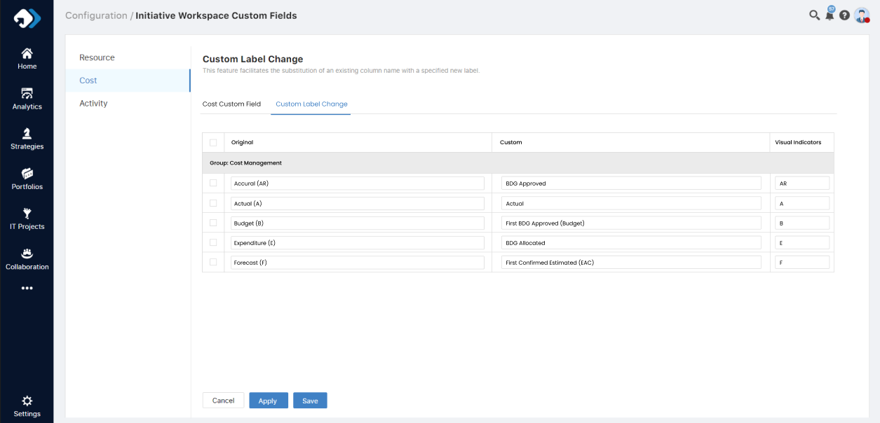

* **Widget Field Enhancement:** Introduced several new fields within the widget to provide users with more comprehensive data insights. These include "BDG Estimated," "BDG Estimated Confirmed (EAC)," "First BDG Approved," "BDG Approved," "BDG Allocated," "Actual," and "BAU Generated."
* **Includes columns:** The widget now includes both Accrual and Expenditure as total values, presented as new columns too.
* **Functionality Alignment:** We have aligned the phasing type and group by functionalities within the widget, streamlining the user experience and improving workflow efficiency.
* **Investments & BAU Comments:** A new widget has been created to accommodate specific fields for POX users, allowing them to input comments and select custom dates for their entries.

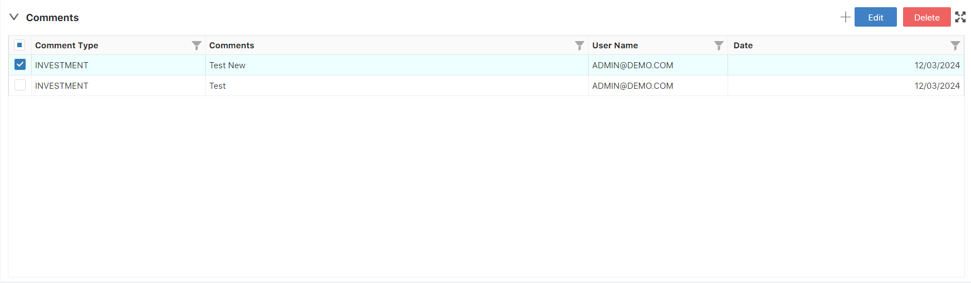

Also, added a new setting for check the expenditure and accrual value:

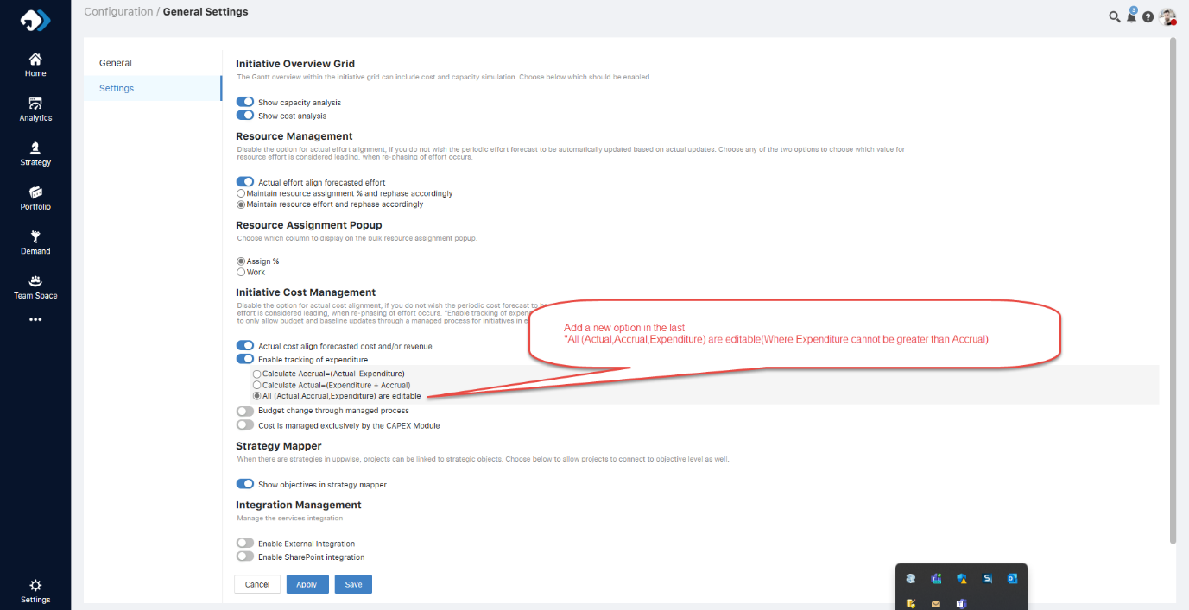

We believe that these enhancements will greatly improve your experience with our platform, providing you with more flexibility and control over your data. Thank you for your continued support and feedback as we strive to deliver the best possible solutions for your needs.